Triggers

-- 1- Auto Correct Grade

alter TRIGGER AutoGrade
ON Stanswer
AFTER INSERT
AS
BEGIN
SET NOCOUNT ON;

UPDATE SA
SET
SA.Gradmarks = CASE

WHEN QP.Qtypes IN ('MCQ', 'True/False') AND SA.StudentAnswer = QP.CorrectAnswer THEN EQ.Qdegree
ELSE 0
END,
SA.IsCorrect = CASE
WHEN QP.Qtypes IN ('MCQ', 'True/False') AND SA.StudentAnswer = QP.CorrectAnswer THEN 1
ELSE 0
END
FROM Stanswer SA
JOIN inserted i ON SA.Ans_id = i.Ans_id
JOIN QuestionPool QP ON SA.Qid = QP.Qid
JOIN ExQuestion EQ ON SA.ExId = EQ.ExId AND SA.Qid = EQ.Qid;

UPDATE SE
SET SE.Obtained_degree = CASE
WHEN CalculatedSum > E.TotalDegree THEN E.TotalDegree
ELSE CalculatedSum
END
FROM StuExam SE
JOIN inserted i ON SE.StdId = i.StdId AND SE.ExId = i.ExId
JOIN Exam E ON SE.ExId = E.ExId
CROSS APPLY (
SELECT ISNULL(SUM(Gradmarks), 0) AS CalculatedSum
FROM Stanswer
WHERE StdId = i.StdId AND ExId = i.ExId
) AS TempTable;

END;

--- Try Trigger 1 ----

INSERT INTO StuExam (StdId, ExId, Total_score, Obtained_degree)
VALUES (15, 1, 100, 0);

INSERT INTO Stanswer (StdId, ExId, Qid, StudentAnswer)
VALUES (15, 1, 1, 'A');
GO

SELECT StudentAnswer, Gradmarks, IsCorrect
FROM Stanswer
WHERE StdId = 11;

SELECT StdId, ExId, Obtained_degree
FROM StuExam
WHERE StdId = 11;

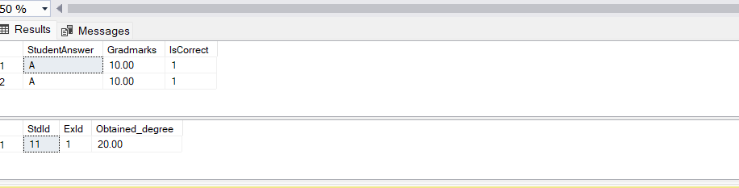

-- 2- Locked Answer After Time

CREATE TRIGGER PreventAnswerAfterTime
ON Stanswer
FOR INSERT, UPDATE
AS
BEGIN
IF EXISTS (
SELECT 1
FROM inserted i
JOIN StuExam se ON i.StdId = se.StdId AND i.ExId = se.ExId
WHERE GETDATE() > se.EndTime
)
BEGIN
RAISERROR ('sorry can not edit your Answer!', 16, 1);
ROLLBACK TRANSACTION;
END
END;
GO

--- Try Trigger 2 ----

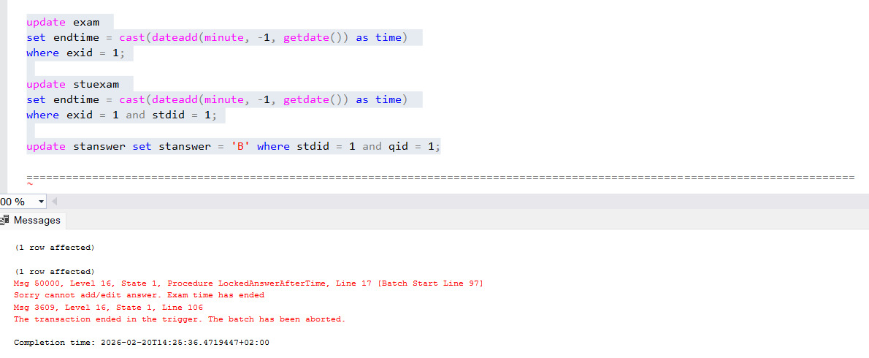

-- 3- Exam Overlap

create trigger preventexamoverlap
on stuexam
for insert
as
begin
if exists (
select 1
from inserted i
join stuexam se on i.stdid = se.stdid
where i.exid <> se.exid
and i.starttime < se.endtime
and i.endtime > se.starttime
)
begin
raiserror ('student is already registered in another exam at this time', 16, 1);
rollback transaction;
end
end;
go

-----Try Trigger 3 ------

insert into stuexam (stdid, exid, starttime, endtime, total_score, obtained_degree)
values (1, 1, '2026-01-01 09:00:00', '2026-01-01 11:00:00', 100, 0);

insert into stuexam (stdid, exid, starttime, endtime, total_score, obtained_degree)
values (1, 2, '2026-01-01 10:00:00', '2026-01-01 12:00:00', 100, 0);
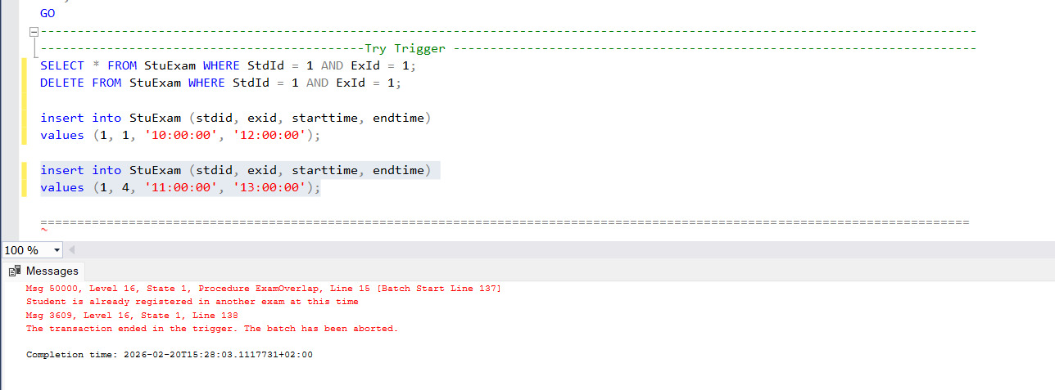

-- 4- grade audit log

create table gradeauditlog (
auditid int identity(1,1) primary key,
stdid int,
exid int,
oldgrade decimal(5,2),
newgrade decimal(5,2),
changedby nvarchar(100),
changedate datetime default getdate()
);
go

create trigger auditgradechanges
on stanswer
after update
as
begin
if update(gradmarks)
begin
insert into gradeauditlog (stdid, exid, oldgrade, newgrade, changedby)
select d.stdid, d.exid, d.gradmarks, i.gradmarks, suser_name()
from inserted i
join deleted d on i.ans_id = d.ans_id;
end
end;
go

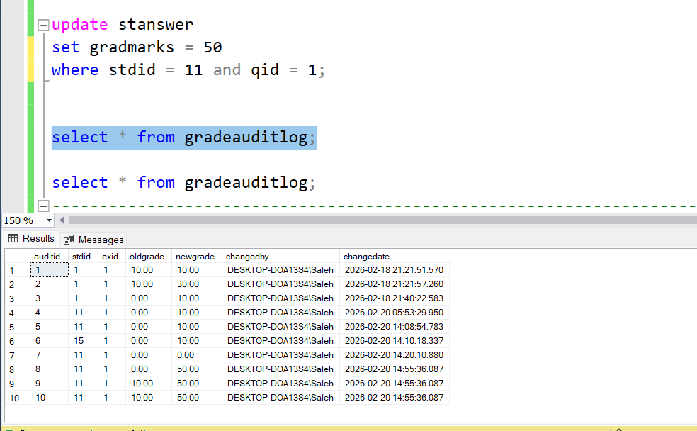
---Try Trigger ----

--- 5- Intake Capacity

create or alter trigger checktrackcapacity
on students
for insert
as
begin

declare @maxcapacity int = 2;

if exists (
select 1
from inserted i
join intake in_tab on i.inid = in_tab.inid
join (
select inid, count(*) as currentcount
from students
group by inid
) s on i.inid = s.inid
where s.currentcount >= @maxcapacity
)
begin
raiserror ('Sorry, the student cannot be added ,The maximum capacity for this track has been reached.)', 16, 1);
rollback transaction;
end
end;
go

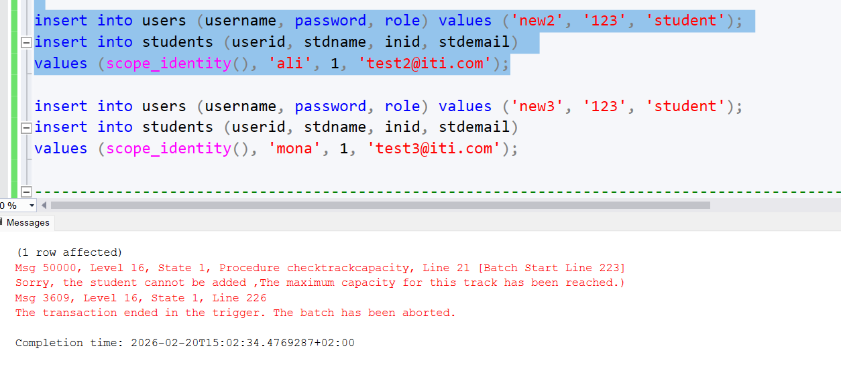
---- try trigger ---

-- 6- protect pool exam
create trigger protectpoolexam
on questionpool
for update, delete
as
begin
declare @currenttime time = cast(getdate() as time);

if exists (
select 1
from deleted d
join exquestion eq on d.qid = eq.qid
join exam e on eq.exid = e.exid
where @currenttime between e.starttime and e.endtime
)
begin
raiserror ('cannot modify questions while an active exam is using them!', 16, 1);
rollback transaction;
end
end;
go

-- try trigger---

update exam set starttime = '00:00:00', endtime = '23:59:59' where exid = 1;

delete from questionpool where qid = 1;

